Trademark Disclosure Form (TDF)
Phase 1: Search and Analysis

Standardized Text

Please provide the exact spelling of the brand name or slogan. This should be something that can be typed on a keyboard. It is case-insensitive, so we usually use ALL CAPS.

Example: COCA-COLA
Type your mark here:

Stylized Text or Image

If your mark can only be described with an image, please provide me with the image. Examples are below, and here are the USPTO format requirements:

The image should be black and white unless coloration is essential
The image must be a .jpg measuring in the range of 250 – 944 pixels in each dimension.
The image should be scanned in the range of 300 – 350 dpi for best results.
The image should have little or no white space around the edges.

By submitting a mark not in compliance with these formats, you consent to hire me to format it for you.

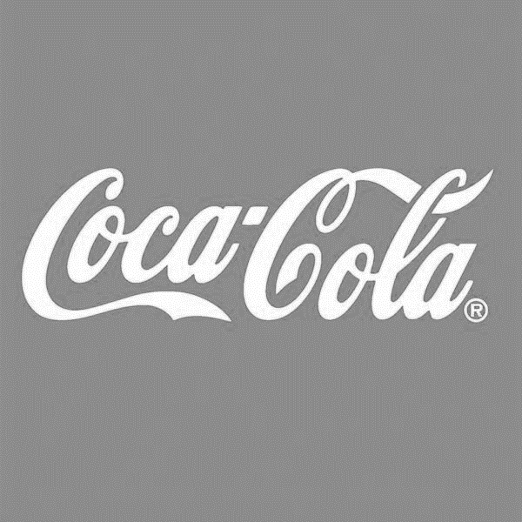 | 
Stylized text | Logo (no lettering, please)

Your past and present use

Are you using this mark for some goods or services that you are currently selling? If so, please answer these questions:

Goods or services

Describe the goods or services that have ALREADY BEEN BRANDED using this mark. (In the past, not the future!) Be as specific and complete as possible.

Example: “Rough-and-Tumble is a clothing line for young men. We have been designing and selling hoodies, jeans, T-shirts, sweats, jackets, ball caps, and knit caps and selling them with a Rough-and-Tumble tag. We sell through e-commerce websites and stock some in local shops in Venice Beach. We do not have our own store.”

Your response here:

Competitors

What are some products or companies that you would describe as your closest competition for the goods or services that you will sell using this mark?

Your response here:

Dates of use

When did you begin using this trademark in commerce for the goods or services above, i.e. in sales or promotions? You must be able to demonstrate continuous use. If you began your sales year ago and then discontinued them, please give only the most recent date that you resumed continuous use.

Your first date of local sales:

Your first date of interstate or internet sales:

Your future intended use

Do you intend to use this trademark for some goods or services that you haven’t sold yet, but you will sell within the next 3 - 4 years? If so, please describe those goods or services here. Be as specific and complete as possible. If next month you tell me, “Oops, I forgot that I really want to sell perfume too” then it could make the application more expensive and complicated for you!!!

Example: Next year, we intend to expand the Rough-and-Tumble brand to women’s jeans and jackets, and we will sell a high-energy sports drink.

Your response here:

Meaning

If you are submitting a name (word or phrase) please explain what this name means to you (if anything), and why you chose it to represent the goods or services that you provide. If it is a non-English word or phrase, please give me the English translation.

Example: “We chose the brand name Rough-and-Tumble because we stonewash our jeans. We also want to suggest that our jeans are appropriate for demanding outdoors activities and people who like to be adventurous.”

Your response here:

Others’ Prior Use

Are you aware of any competitors who are using a similar trademark to sell a similar good or service?

Example: “There’s an Instagram profile for ‘Rough and Ready’ jeans. There’s also a ‘Rough and Tumble’ clothing store in Kansas City. They only sell children’s clothes.”

Your answer:

How did you search to find competing marks? (General awareness, Google / social media search, trademark search, etc.)

Your answer:

